RBSA Photography Prize Exhibition 2021
3 September – 16 October
Sponsored by The Galliard Apsley Partnership
About this exhibition
The RBSA Photography Prize exhibition invites artists creating work in the photographic medium to enter. We welcome entries from professional and emerging artists based in the UK and internationally. There are 4 prizes to be won including £1,000 1st Prize, £500 2nd Prize, £250 3rd Prize and a solo exhibition at the RBSA Gallery.
The Photography Prize exhibition will be on display both in the RBSA Gallery and online to ensure access to those who want to enjoy the exhibition from home.
Selection for the Photography Prize is by digital image of the original artwork only. All works entered go through the same selection process. No artists, including Members & Associates of the RBSA, are automatically selected.
All entries will be judged by a distinguished panel of independent judges who will make their selection based on the quality and technique of the work. This year’s exhibition will be selected by Jennie Anderson, Director of Argentea Gallery, Nicola Shipley, Director, GRAIN Projects and Stephen J Morgan, Artist.
Key Dates
- Entry Deadline: Wednesday 16 June, 4pm
- Selected artists announced: Friday 9 July
- Delivery of work: Sunday 29 August, 10.30am - 4pm
- Exhibition Dates: Friday 3 September – Saturday 16 October
- Collection of work: Sunday 17 October
Prizes
GMC Trust First Prize: £1,000
Frame Creatives Second Prize: £500
GMC Trust Third Prize: £250
Solo Exhibition in the RBSA Gallery Ground Floor Exhibition Space Up to 6 Highly Commended certificates will also be awarded.
This exhibition is sponsored by The Galliard Apsley Partnership. The RBSA thanks each donor for their generous support, which is greatly appreciated.

Entry Fees
Artists may enter up to four pieces of work.
• Free for Next Wave Associates

1 entry: £19
2 entries: £32
3 entries: £40
4 entries: £48

Artists must submit work through the online entry form:
RBSA Photography Prize Entry Form
Payments
- Payment can be made by PayPal through the entry form
- Payments can be made in person by cash or card at the RBSA Gallery
- Card payments can be taken over the phone, call 0121 236 4353
Entry Requirements
- Work submitted must be in the photographic medium
- Digital art is accepted
- Moving image work is not accepted
- All work must be for sale
- All entrants must be over the age of 18 on the closing date for entries
- If your work is over 180cm in any dimension, please contact the Gallery
- Work using found photographs is accepted if no copyright laws are violated
- Any manipulation of the image must have been carried out by the artist
- The decision by the panel of judges is final, no correspondence will be entered into
- Ideally all works that are selected for the exhibition need to be framed. If this is not the case the artists will need to contact the Gallery in advance and explain how their work fixes/hangs. We cannot have loose unframed prints pinned to the wall.
- By completing the entry form you agree to the terms and conditions of this exhibition
- Digital image file(s) must be JPG, tiff or PNG, at least 1000px and filenames must include the artist’s name and title of artwork

Notification of Selected Artwork
Selected artists will be emailed by the Gallery to notify them of which works have been selected on Friday 9 July. Further details regarding the delivery and collection of work will be included in this email. The selected list will also appear on the RBSA website by Friday 9 July. Please check you Junk mailbox to ensure you have not missed an email from us. If you do not receive an email from us and you are not on the selected list, unfortunately you have not been selected.

Delivery of Selected Artwork
Deliver your original work(s) labelled and unwrapped to the Gallery on
Sunday 29 August, 10.30am - 4pm
To reduce numbers in the gallery for the hand-in, delivery times have been ordered by surname. Please try to arrive in your surname slot (if you are delivering for more than one person, you can deliver both at the same time).
A-H: 10.30 - 12pm I-P: 12 - 2pm Q-Z: 2 – 4pm
- Two labels must be attached to each work (see below)
- Delivery is only allowed outside the dates and times listed in exceptional circumstances and by prior arrangement
- A third party or courier can deliver on your behalf
- Please clearly highlight the ‘top’ of abstract works
- Frames must be suitable for display using a mirror-plate system. If you wish to enter a work that is unsuitable for mirror plating, please inform the Gallery
- Unframed prints or work in clip frames cannot be entered
- Frames must have no projections at the back (such as rings)
Sale of work
All work entered must be for sale.
Artists will be paid approximately 30 days after the last day of the exhibition or receipt of payment from the customer, provided payment from the purchaser has been received in full.
- The price stated on the entry form must be the retail price and include the frame
- The commission is 35% + VAT for all artists
- Commissions as a result of being exhibited at the RBSA Gallery will be subject to the same commission
- Limited edition prints (framed or unframed) of selected work may be sold if details are completed on the entry form. Artists will be informed of any order placed and will be responsible for delivering these to the Gallery or to the purchaser. The purchaser will pay the cost of postage if the purchase is made online. Orders must be fulfilled within 30 days of notification
- Where possible sold items will remain on display until the end of the exhibition. At the Gallery’s discretion, when requested by the purchaser, sold items may be removed on the day of purchase
- Diptych and triptych works must be sold as one
- Sold work that has a damaged frame must be replaced promptly by the artist.
The RBSA reserves the right to deduct reframing costs from an artist’s commission if required
Commission and VAT calculation
Artists Price* x 100 / 58 = retail price
*This is the total amount the artist will be paid

Labelling your work

Two completed labels must be attached to each selected work.

Label 1
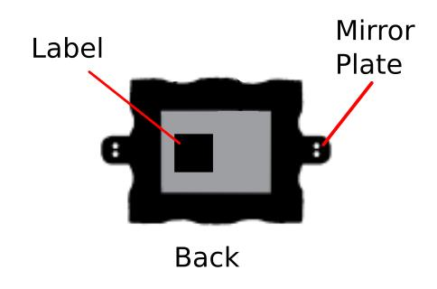
Fix the first label securely on the back of your work.

Label 2
Attach the second label to a string, fix one end to the back of the work, ensuring that the label can hang over in front of work.
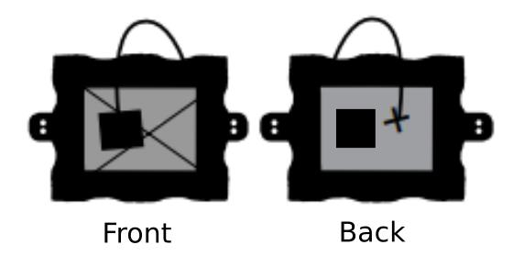

Hanging system information
Artists should affix mirror plates at the mid-point on the frame of each work, as shown.
If work to be submitted is unsuitable for mirror plates, please advise the Gallery to inform the Honorary Curator.

Example labels to be printed or duplicated:
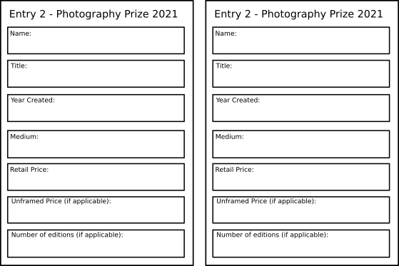
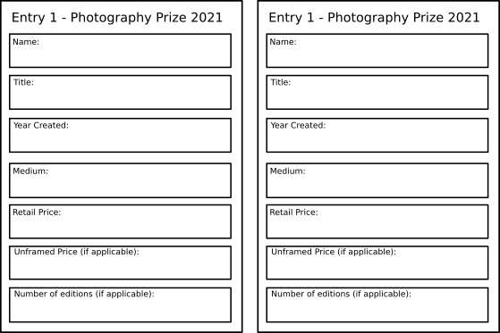
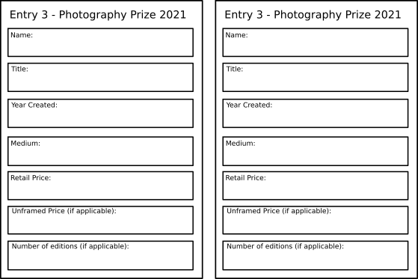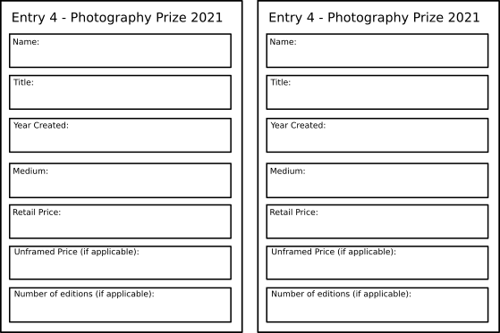
Collection
Sunday 17 October
• A third party or courier can collect on your behalf.
Images of work
Visitors are permitted to take photographs in the Gallery without restriction. Copyright remains with the artist. However, by entering this exhibition you agree that photos of your work can be used for the promotion of the RBSA Gallery and its exhibitions in perpetuity.
Insurance
Reasonable care will be taken of all work, but it is submitted at your own risk. We strongly advise all artists to insure their work against damage and theft. The RBSA cannot insure work on the premises or in transit and will not be responsible for any loss or damage.
COVID-19
It has been our policy to keep the gallery open wherever possible, but should the Government impose further limitations on the opening of galleries & museums in England, we may need to restrict operations. We will inform artists as soon as possible should any changes occur, but you may find it helpful to view the RBSA website and social media accounts for updates before contacting the gallery.

